FÍS PROJECT CLINIC

Guidelines & Application Form

- Applicants may apply with an original or adapted concept for a live action television drama, TV single, mini-series etc. All dramas and mixed genres are accepted (drama, comedy, crime thriller, sci-fi, sci-fi/horror...);
- The Project (Primary Project) must be in active development ideally with market interest attached (third party development funding from a broadcaster, funding agency etc. or commitment of a broadcaster, streamer, funding agency, sales agent or distributor). Projects with market interest are likely to be prioritised;
- Applicants may apply with a project intended to be produced Irish or English (please note the materials submitted and feedback must be through English);
- The following editorial materials must be available for each project and will be assessed during the Clinic(s):
John Yorke Clinic | David Clarke Clinic
- PDF of Series Bible of Primary Project (up to 10 pages)  - PDF Episode One treatment (Up to 10 pages)  - Producer or Company Bio (Up to 1 page)  - Third Party Letter of Interest (optional) | - PDF of Series Bible for Primary Project (Up to 10 Pages)  - PDF with one paragraph on three additional projects on your company slate (Up to 2 pages)  - Producer or Company Bio (up to 1 page)  - Third Party Letter of Interest (optional)

- Applicants may apply as an individual or in a team. Teams may be made up of the writer(s), producer(s) and/or director(s). Applicants must be at least 18 years old. Students in full time education are not eligible to apply. All team members selected for the John Yorke Clinic must be available to attend their individual virtual session in late February 2022. All team members selected for the David Clarke Clinic must be available to attend a virtual industry briefing plus individual session at the allotted times in late February 2022. Applications are limited to 2 per applicant for the John Yorke Clinic and 1 per applicant for the David Clarke Clinic. Open to Irish individuals/teams/companies only.
- Please complete and return the following requirements as outlined below to kenny@galwayfilmcentre.ie by 12pm on Monday 24th January 2021. Late or incomplete applications will not be accepted.

John Yorke Clinic Application:
- Completed Form (One per project)
- Pdf of the Series Bible (max 10 pages)
- Pdf of Pilot Episode Treatment (max 10 pages)
- Individuals and/or Company Bio (max 1 page)
- Evidence of market support or third-party support / Letter of Interest

David Clarke Clinic Application:
- Completed Form (One per application)
- Pdf of the Series Bible (max 10 pages)
- Pdf of one paragraph on three additional slate projects (Up to 2 pages)
- Individuals and/or Company Bio (max 1 page)
- Evidence of market support or third-party support / Letter of Interest for Primary Project

Up to eight projects/slates will be selected to receive the unique opportunity of a free one-to-one session with John Yorke or David Clarke.
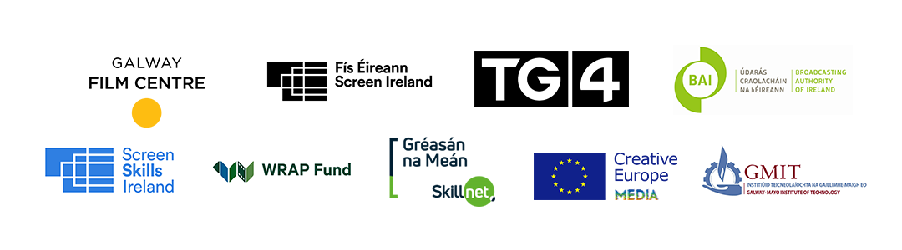

CLINIC SELECTION

Please indicate which Consultant’s Clinic you wish to apply to:

CONSULTANT | DETAILS | RESPONSE (please delete as appropriate)
John Yorke Clinic | Editorial Feedback on 1 Project | Yes / No
David Clarke Clinic | Market Feedback on 1 Project (in depth) plus review of up to 3 further projects | Yes / No
Both John York & David Clarke * | Editorial Feedback on 1 Project plus Market Feedback on 1 Project (in depth) plus review of up to 3 further projects | Yes / No
*If you are applying for both clinics, please ensure that you supply all the requirements for each as outlined below.

APPLICANT DETAILS

NAME OF APPLICANT
COMPANY NAME (IF APPLICABLE)
ADDRESS
TELEPHONE
EMAIL
WEBSITE

DIVERSITY DETAILS*
*Please note this section is not mandatory.
WHAT BEST DESCRIBES YOUR GENDER?

Please note this section is not mandatory, please include prefer not to say if you do not want to disclose this information.

A CORE AIM OF THE NATIONAL TALENT ACADEMY FOR FILM & TV IS TO SUPPORT DIVERSE AND REGIONALLY BASED TALENT. WE ENCOURAGE APPLICATIONS FROM TALENT WHO IDENTIFY AS DIVERSE OR WHO ARE HABITUALLY RESIDENT IN THE REGIONS.

IF YOU WOULD LIKE TO PROVIDE US WITH ADDITIONAL INFORMATION ON YOUR BACKGROUND, PLEASE DO SO HERE.

PROJECT / PRIMARY PROJECT DETAILS
CURRENT TITLE

TYPE OF PROJECT
(EG. LIVE ACTION DRAMA, COMEDY SERIES ETC)

PROJECT DURATION
(i.e. 6 x 30 minutes, 4 x 1 hours etc.)

MARKET INTEREST DETAILS
NAME OF THIRD PARTY ORGANISATION IF ATTACHED
NAME OF PROJECT EXECUTIVE/MANAGER/COMMISSIONER
AT THIRD PARTY ORGANISATION
NATURE OF THIRD PARTY ORGANISATION SUPPORT
(development funding, letter of commitment etc.)

ORIGINS OF THE PROJECT (DELETE Yes or No AS APPROPRIATE)
ORIGINAL IDEA | Yes / No
ADAPTATION OF UNDERLYING MATERIAL | Yes / No
IF THIS PROJECT IS AN ADAPTATION, HAVE THE RELEVANT RIGHTS BEEN ACQUIRED? | Yes / No

LOGLINE
(25 WORDS APPROX)
DETAILED SYNOPSIS
(UP TO 500 WORDS)

PLEASE OUTLINE WHY
YOU WISH TO PARTICIPATE
IN THE FÍS PROJECT CLINIC
(UP TO 500 WORDS)

INDIVIDUAL/TEAM DETAILS
NAME | ROLE | MOBILE | EMAIL | GENDER
 |  |  |  | F/M/Prefer not to say
 |  |  |  | F/M/Prefer not to say
 |  |  |  | F/M/Prefer not to say
 |  |  |  | F/M/Prefer not to say

DATA PROTECTION
The Galway Film Centre (GFC) administers the Fís Project Clinic and is required to collect data to process your application. GFC is committed to protecting and respecting your privacy and will therefore ensure that all information that you provide to us is safeguarded. GFC only requests data that is legitimate and for which we have a valid legal basis to process to facilitate the processing of your application. GFC requests that you provide professional information only and do NOT send personal data on yourself or third parties, associated with your application, that has not been requested, or that you have not acquired permission to use. The data may be used for statistical purposes. The data collected may be stored, processed and passed in confidence to or shared with third parties, individuals or organisations, who are involved in the assessment of applications or monitor funding.
All information will be treated in accordance with the GDPR and associated data protection laws. You have rights under the GDPR including the right to ask for a copy of the information held by GFC and the right to require GFC to correct any inaccuracies in your information.

CONSENT

I/WE CONSENT TO THE DATA PROVIDED BEING PROCESSED FOR  THE PURPOSES OUTLINED ABOVE/ | Signature(s)

DECLARATION

I/WE DECLARE THAT THE INFORMATION PROVIDED IN THIS  APPLICATION IS TRUE AND CORRECT TO THE BEST OF MY/OUR KNOWLEDGE AND I/WE HAVE OBTAINED THE PERMISSION OF ANY OTHER INDIVIDUALS LISTED TO PROVIDE THEIR PROFESSIONAL INFORMATION. | Signature(s)
DATE

Please tick yes if you would like to sign up to the GFC mailing list and be one of the first to hear about all upcoming news, events and courses.

YES NO

Please email the completed application form and all appropriate material (in pdf format) to kenny@galwayfilmcentre.ie on or before 12pm on Monday January 24th 2022.

