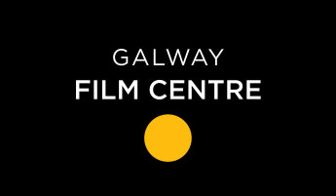

SHORT FILM COMMISSION APPLICATION FORM 2019

***Closing date for all applications is 3pm, Friday 28th June 2019 ***

Please tick as appropriate, are you the:
- Writer

- Director
- Producer

NAME: _________________________________________

ADDRESS: _________________________________________

_________________________________________

TELEPHONE NO: _________________________________________

EMAIL: _________________________________________

FILM TITLE: _________________________________________

The Galway Film Centre (GFC) is required to collect data to process your application. GFC is committed to protecting and respecting your privacy and will therefore ensure that all information that you provide to us is safeguarded. GFC only requests data that is legitimate and for which we have a valid legal basis to process to facilitate the processing of your application. GFC requests that you provide professional information only and do NOT send personal data on yourself or third parties, associated with your application, that has not been requested, or that you have not acquired permission to use. The data may be used for statistical purposes. The data collected may be stored, processed and passed in confidence to or shared with third parties, individuals or organisations, who are involved in the assessment of applications or monitor funding.

All information will be treated in accordance with the GDPR and associated data protection laws. You have rights under the GDPR including the right to ask for a copy of the information held by GFC and the right to require GFC to correct any inaccuracies in your information.

Please tick yes if you would like to sign up to the GFC database and be one of the first to hear about all upcoming news, events and courses.
Yes No

SIGNATURE OF APPLICANT: _______________________________________

