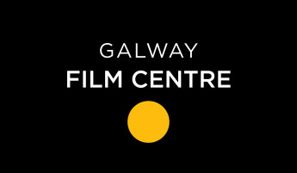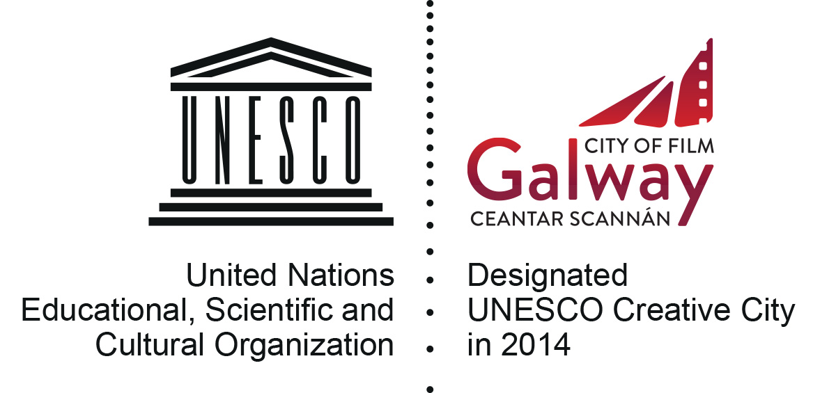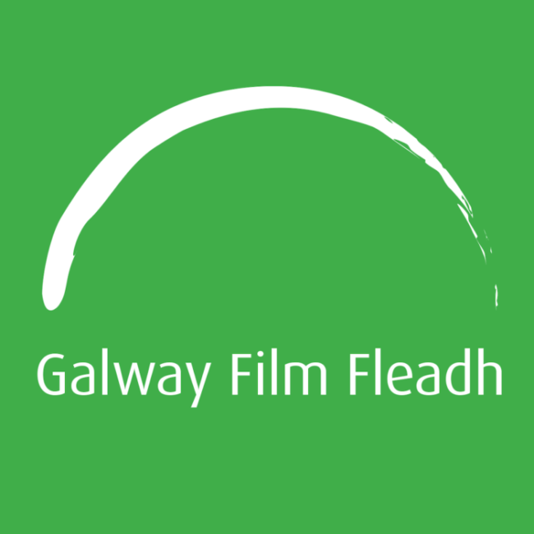

ONE MINUTE FILM FESTIVAL APPLICATION FORM 2020

**Closing date for all applications is 4pm (GMT) Wednesday 3rd June 2020***

Please tick as appropriate, are you the:
- Writer

- Director

- Producer
- Other (please specify) ______________________________________

NAME: _________________________________________

TELEPHONE NO: _________________________________________

EMAIL: _________________________________________

FILM TITLE: _________________________________________

FILM LINK: _________________________________________
(If applicable please include the password for the film link)

The Galway Film Centre (GFC) is required to collect data to process your application. GFC is committed to protecting and respecting your privacy and will therefore ensure that all information that you provide to us is safeguarded. GFC only requests data that is legitimate and for which we have a valid legal basis to process to facilitate the processing of your application. GFC requests that you provide professional information only and do NOT send personal data on yourself or third parties, associated with your application, that has not been requested, or that you have not acquired permission to use. The data may be used for statistical purposes. The data collected may be stored, processed and passed in confidence to or shared with third parties, individuals or organisations, who are involved in the assessment of applications or monitor funding.

All information will be treated in accordance with the GDPR and associated data protection laws. You have rights under the GDPR including the right to ask for a copy of the information held by GFC and the right to require GFC to correct any inaccuracies in your information.

Please tick yes if you would like to sign up to the GFC database and be one of the first to hear about all upcoming news, events and courses.
Yes No

SIGNATURE OF APPLICANT: _______________________________________

